Steps for load Sample Database

Step 1

Connect to the SQL Server by (1) choosing the server name, (2) enter the user and (3) password and (4) click the **Connect** button.

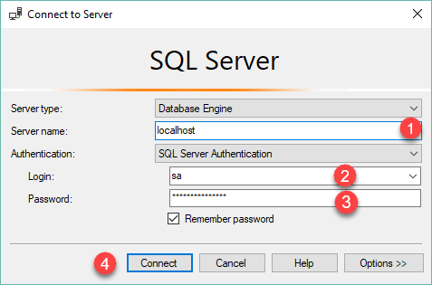

Step 2

Right-click the **Databases** node in the **Object Explorer** and select the **New Database…** menu item

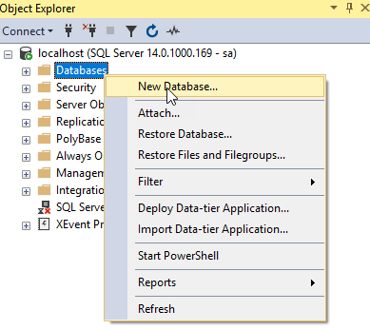

Step 3

(1) Enter the **Database name**as BikeStores and (2) click the **OK** button to create the new database.

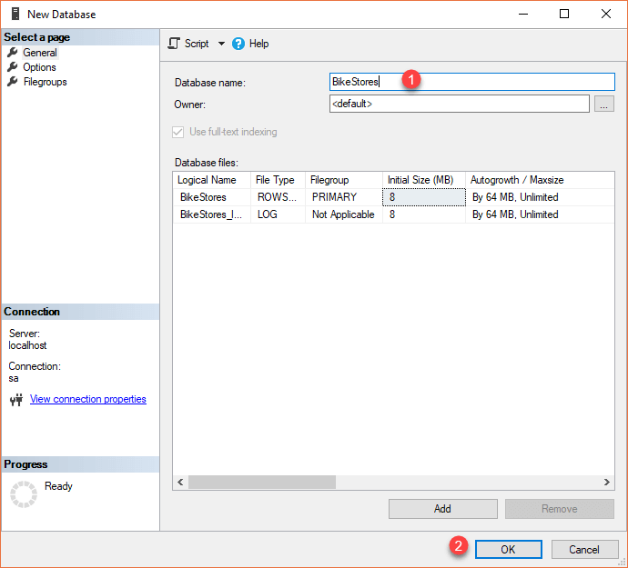

Step 4

If everything is fine, you will see the database **BikeStores** appears under Databases node as shown in the screenshot below:

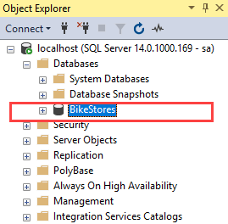

Step 5

From the File menu, choose Open > File… menu item to open a script file.

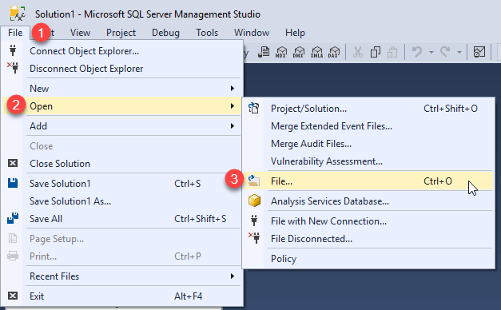

Step 6

Select the **BikeStores Sample Database – create**objects.sql file and click the Open button

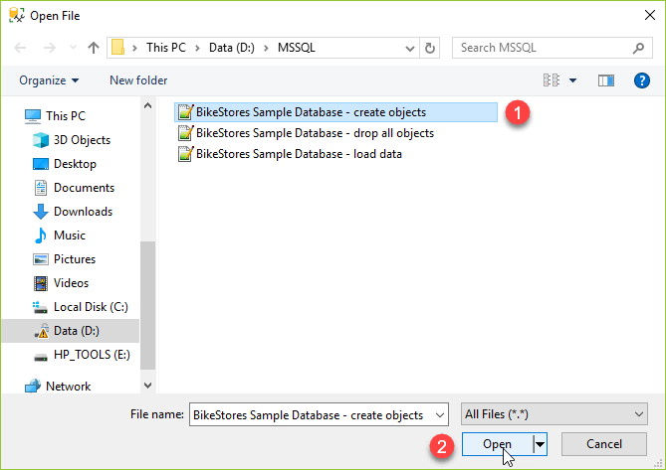

Step 7

Click the **Execute** button to execute the SQL script.

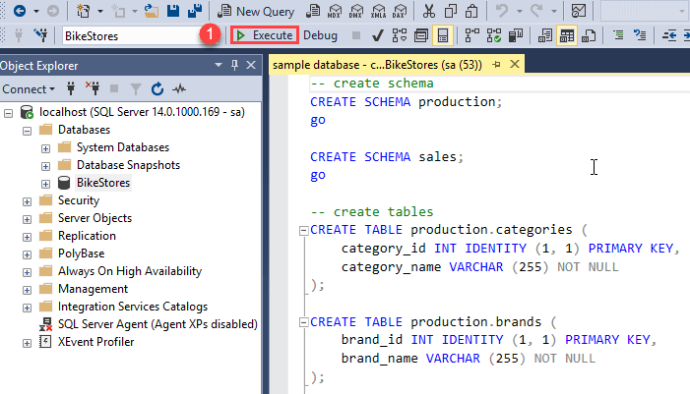

You should see the following result indicated that the query executed successfully.

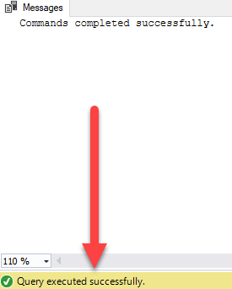

If you expand the **BikeStores > Tables**, you will see the schemas and their tables are created as shown below:

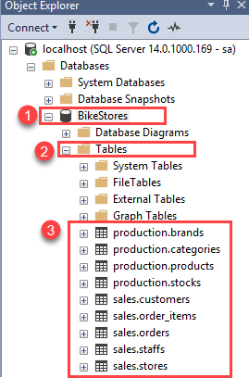

Step 8

Open the file for loading data into the tables.



Step 9

Choose the **BikeStores Sample Database – load data.sql** file and click the Open button.

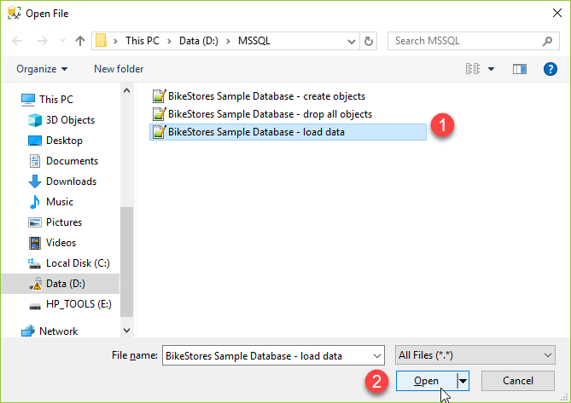

Step 10

Click the **Execute** button to load data into the tables.

You should see the following message indicating that all the statements in the script were executed successfully.

